**#WhatsYourTake**

**March 2020**

The *#WhatsYourTake* online survey is carried out three times each year to gather young people’s views on current issues. This *#WhatsYourTake* survey was open from 21st February until 25th March 2020, and asked questions on the following topics:

* Circular Economy – *‘Disposing of a Disposable Society’.*
* Youth Justice Strategy.
* Race and employment in Scotland – *‘Equally Employed’.*
* Political literacy and citizenship in schools
* Protection of workers in shops or selling age-restricted goods and services.
* Just Transition – ‘*Feeding Scotland Sustainably’.*

This report gives an overview of the key findings from the March 2020 *#WhatsYourTake* survey.

**Respondent Profile**

**287** young people took responded to the *#WhatsYourTake* survey in March 2020.

*Of these:*

* **80.5%** are aged between 12 and 17, 10.1% are aged 18-20, and 9.4% are aged 21-25.
* **63.1%** identify as female, **32.4%** identify as male, **1.4%** identify as non-binary, and **0.7%** prefer to use their own term. Theremaining respondents preferred not to say.
* **78.7%** are at school, **17.1%** go to university or college, **16.4%** are in full time or part time work, **3.1%** are doing an apprenticeship, **2.4%** are not in education or training, and **1.0%** are in other activities such as caring roles or volunteering.
* Respondents came from **31 local authorities**, [**our 11 national voluntary organisations**](https://syp.org.uk/get-involved/join-us/), and various others representing a diverse range of communities of interest and lived experience (including youth voice organisations, student unions, a range of cadets, and various sports clubs).

*This report was compiled by Rosy Burgess, SYP Events and Campaigns Officer –* [*rosy.b@syp.org.uk*](mailto:rosy.b@syp.org.uk)*.*

**Recommendations**

Based on the findings from the March 2020 *#WhatsYourTake* survey, the Scottish Youth Parliament makes the following recommendations:

**Circular Economy – *‘Disposing of a Disposable Society’.***

1. More effort should be made to increase young people’s awareness of the ‘circular economy’ and the circular economy debate. It is important that young people are educated on environmental issues affecting them so they can make informed decisions in their daily lives.
2. Funding should be available to support the development of sustainable fashion and technology to make this an accessible and viable option, and to enable young people to shop in a more sustainable way.

**Youth Justice Strategy.**

1. The Scottish Government and other partners should prioritise mental health and children’s rights to support young people who are involved in offending. Support for victims should also be prioritised.
2. The law should be changed to allow all 16 and 17 year-olds to be considered in the Children’s Hearings System.

**Race and employment in Scotland – *‘Equally Employed’.***

1. Work experience and placements should be made available to young people from minority ethnic backgrounds.
2. Interview skill development opportunities, apprenticeships, and peer support / network groups should be made available to young people from minority ethnic backgrounds.

**Political literacy and citizenship in schools**

1. Citizenship education should be included in Personal and Social Education (PSE) classes for all young people in high school.
2. Young people should be involved in discussions about citizenship education, as it will have a direct impact on their learning experience and education.

**Just Transition – ‘*Feeding Scotland Sustainably’.***

1. Steps should be taken to support suppliers and consumers to reduce and recycle food waste.
2. Sustainable and locally sourced produce should be subsidised to bring the cost in line with less environmentally-friendly products, to make it more affordable for everyone, and to enable people to buy local and seasonal produce.
3. Support should be provided for farmers through subsidies to ensure farming methods are sustainable, and to enable diversification to more environmentally sustainable farming methods or products.

**‘Disposing of a Disposable Society’**

The Scottish Government recently consulted on a potential Circular Economy Bill. This proposed legislation includes measures to cut litter and waste, and forms part of wider plans for a new approach to reducing, reusing and recycling materials to help drive Scotland’s circular economy.

These questions were designed to help the Scottish Parliament’s Environment Climate Change and Land Reform Committee consider the issues of consumerism and waste (fast fashion; fast food; disposable society) and how this impacts young people as consumers and responsible citizens.

|  |
| --- |
| “It is interesting that many young people said they are restricted by the cost of items and that they would buy more sustainably if it was cheaper to do so - it’s important that sustainable fashion is made more accessible for young people as it allows us to be a part of a more environmentally friendly society. I also believe it is important that young people are involved in general discussions about the circular economy. I was surprised by how few young people have an understanding of the term considering its importance in the environmental actions our government is currently debating.”  – Thea Tjolle MSYP, Convener (External Affairs, UK, and International) |

***‘Have you heard the term ‘circular economy’?’***

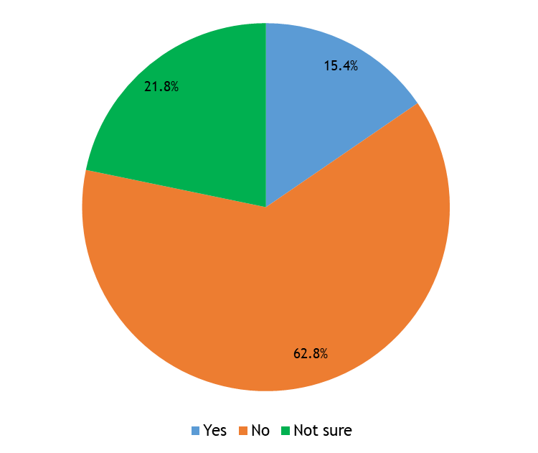

Nearly **two thirds of young people** have not heard the term ‘circular economy’.

Young people who have heard this term understand it to mean:

* Turning waste products into something else.
* An economy revolving around products that can be reused.
* Recycling everything to minimise the amount of waste.
* Focusing on reusing items rather than creating and buying new.

***Thinking about the definition of a ‘circular economy’, what would encourage you to shop in a more sustainable way?’***

Respondents were asked to select their top three choices from a list, as shown on the next page. Over half of the young people who responded to this survey would be encouraged to shop in a more sustainable way if sustainable fashion and technology were **cheaper**. Around one third of respondents would be encouraged to shop in a more sustainable way if more sustainable fashion and technology were **available**, or if they knew how sustainable fashion and technology were **better for the environment**.

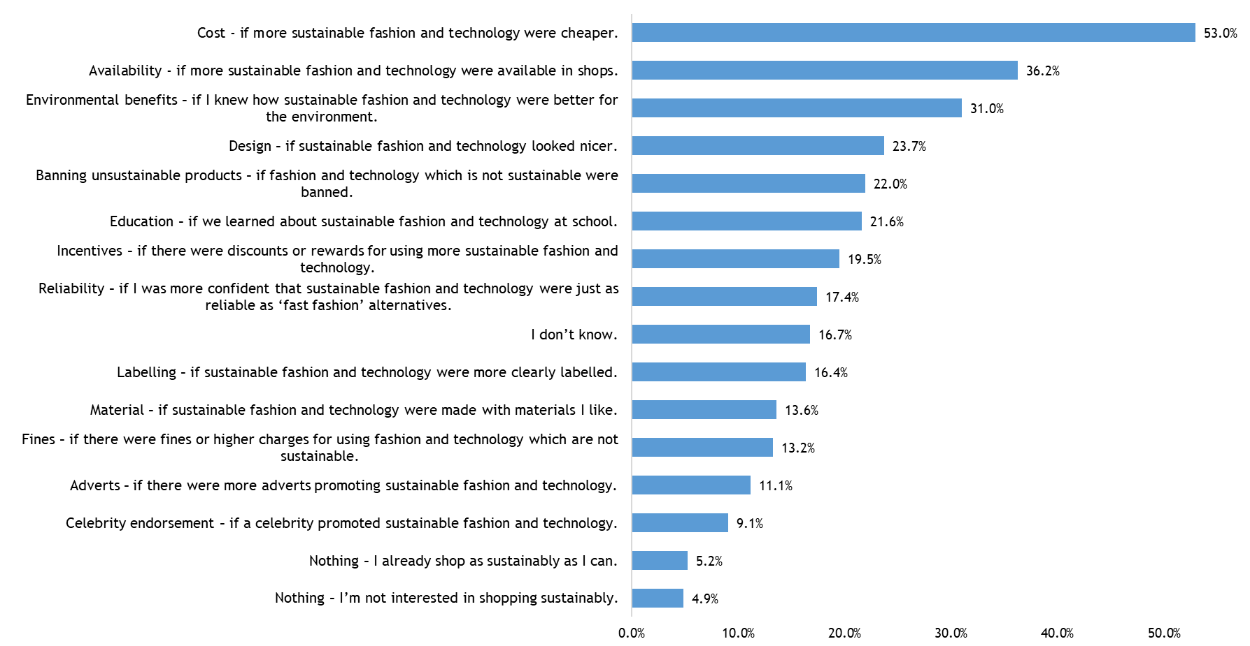

**Youth Justice Strategy**

How should Scotland respond when children and young people get into trouble with the law? How do we prevent offending in the first place? How do we get young people out of justice systems and on to positive destinations? How do we get better experiences and results for young people and victims?

After five years, Scotland’s youth justice strategy - ‘Preventing Offending – Getting it Right for Children and Young People’ needs to be refreshed and future-proofed. These questions asked young people to identify the main priorities for the two years from June 2020.

|  |
| --- |
| “I find the fact that over 75% of young people in Scotland want the law to be changed to allow all 16 and 17 year-olds to be considered through the Children’s Hearings System very interesting and very important. I very much like that a lot of them finding their rights important. I think it’s crucial to get young people involved because they are the key people being affected by this, and many are probably not educated around the children's hearing system as much. I think it's great how much they think it needs to be re-looked at.”  – Lauren Kelly MSYP, Deputy Convener (Education and Lifelong Learning) |

**‘*What do you think the main priorities should be for Scottish Government and other partners to support young people who are involved in offending?*’**

Respondents were asked to select their top three choices from a list, as shown below.

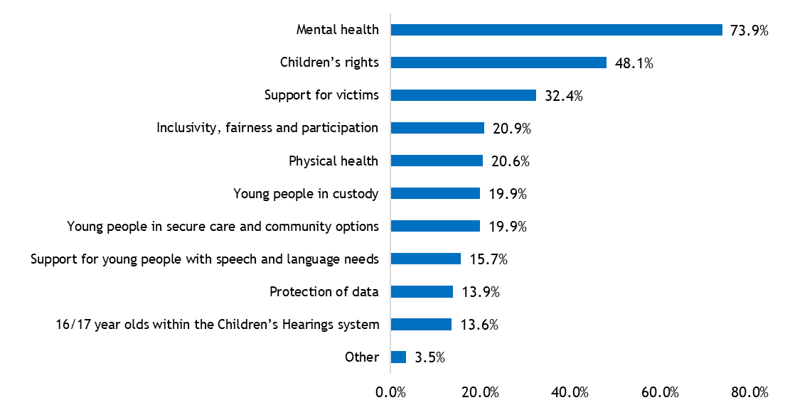

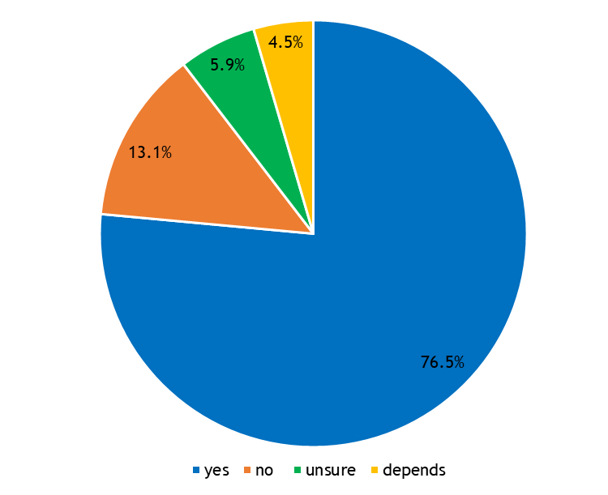**‘*Currently, not all 16 and 17 year olds are able to be considered through the Children’s Hearings System. Should the law be changed to allow all 16 and 17 year-olds to be considered in this system?’***

This was an open-ended question which received 221 responses. Responses were coded either ‘yes’, ‘no’, ‘not sure’, or ‘depends’.

**Over three quarters of respondents** **agree** the law should be changed to allow all 16 and 17 year-olds to be considered in the Children’s Hearings System. Overall, the majority of comments focused on the age at which a young person is considered to be an adult, and the level of support young people would receive through the Children’s Hearings System compared to the adult system.

**‘Equally Employed’**

Minority ethnic communities face poorer outcomes than the majority of Scots, including in-work poverty and lower employment. Despite having high levels of educational attainment, people from minority ethnic communities are twice as likely to be unemployed than white communities. It’s often in work places that racism and discrimination are evident.

These questions were asked to help the Scottish Parliament’s Equalities and Human Rights Committee identify what actions employers should take to enable young people from ethnic communities to access employment opportunities, and to ensure they are employed in jobs appropriate for their level of skills, qualifications and experience.

|  |
| --- |
| “The thing I found most interesting, however not surprising, is how many young people have highlighted that they need work experience and interview skills. As someone who is part of the ethnic minority, being a white migrant, I know the struggle of not having had these opportunities. This topic is so important because there are so many people who come from other countries to work here, and they don’t always get to work because of their background and where they are from. They don’t always have opportunities and experiences because no one is willing to give it to them, simply because they have a different skin colour or speak a different language. To me, everyone should have an equal amount of opportunities to work and get the money they need to live. “  – Wiktoria Orlicka MSYP, Convener (Culture and Media) |

**‘*What training and development opportunities should be made available to young people from minority ethnic backgrounds?*’**

Respondents were given a list of options and were asked to select those they felt would be meaningful and helpful, as shown below.

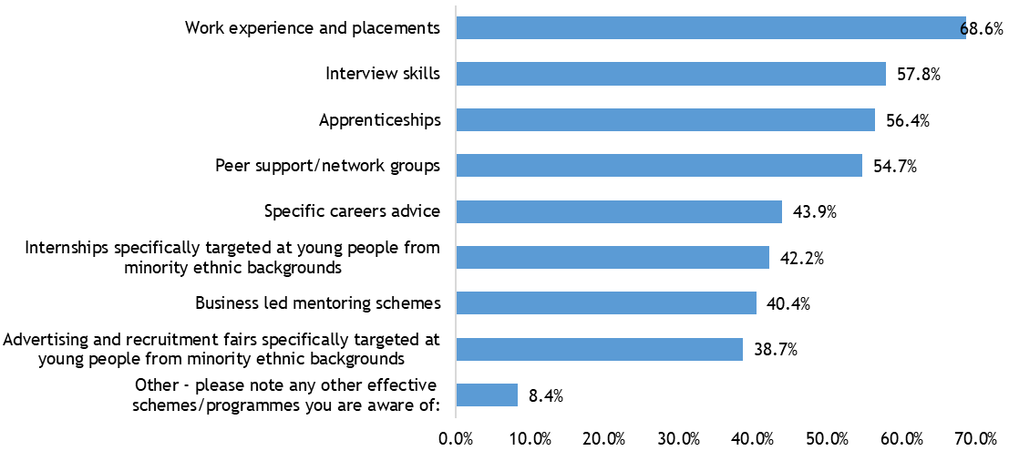

**‘*What ways do employers currently link in with your school, university, college or workplace and how could these be improved?’***

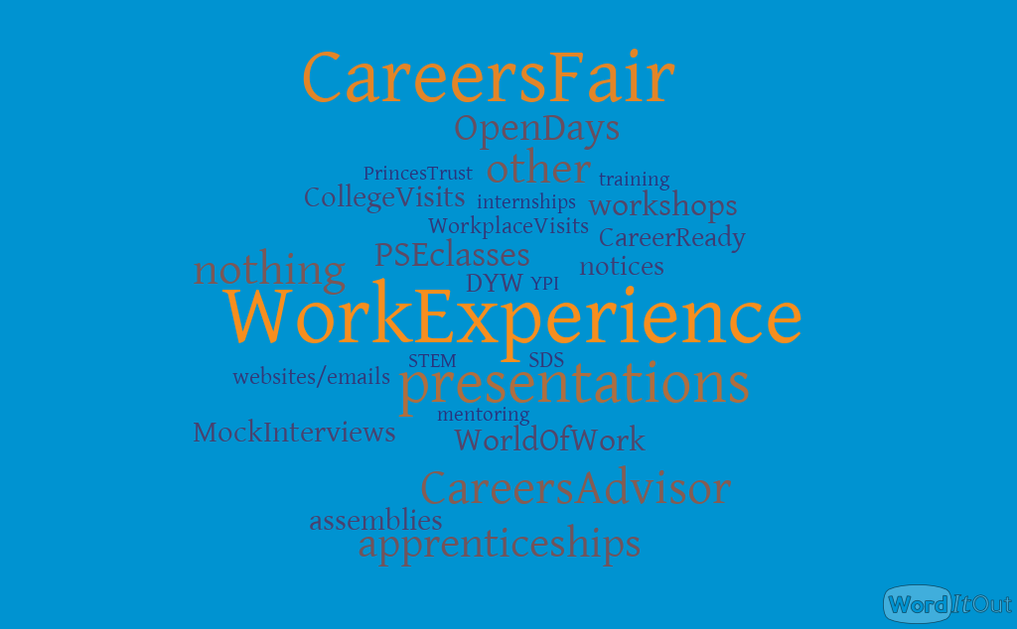

140 young people responded to this question.

Excluding those who said ‘I don’t know’ (27 respondents), the most common ways in which employers currently link in with schools, universities, colleges, or workplaces is through **work experience** and **careers fairs**. Some young people have been to **presentations by an employer**, and others have seen a **Careers Advisor**.

A range of **external organisations or programmes** were mentioned to help young people find out about employers and careers, including World of Work, Developing the Young Workforce (DYW), Career Ready, Skills Development Scotland, YPI Scotland, and Princes’ Trust.

Due to the format of the question it is difficult to identify whether young peoples’ responses relate to current links or suggestions for improvements. However, a small number of young people suggested they would like **careers fairs or open days to be held more often**, with a **wider range of employers**; there should be **more variety in the types of careers promoted to young people**; and more **time with careers advisers and on work experience placements**.

**Political Literacy and Citizenship in schools**

In 2012 Education Scotland reported that ‘In a number of schools, where modern studies is not taught as a discrete subject, young people’s entitlement in the area of people in society, business and economy is not being fulfilled. In these schools, it is proving difficult for young people to acquire the appropriate knowledge or skills, for example in relation to democracy and political literacy.’

These questions will help the Scottish Parliament’s Education and Skills Committee find out about young people’s experiences of Modern Studies and citizenship education in schools.

|  |
| --- |
| “We found the finding about covering Citizenship in PSE really interesting. We were quite shocked by the fact over half of the respondents had never covered citizenship in a PSE class. It's important for young people to be involved in the discussions about citizenship education as it will have a direct impact on their learning experience and education.”  - Aaran McDonald MSYP, Convener (Transport, Environment, and Rural Affairs) and Liam Fowley MSYP, Convener (Education and Lifelong Learning) |

***‘Was Modern Studies offered in your school as a stand-alone subject?’***

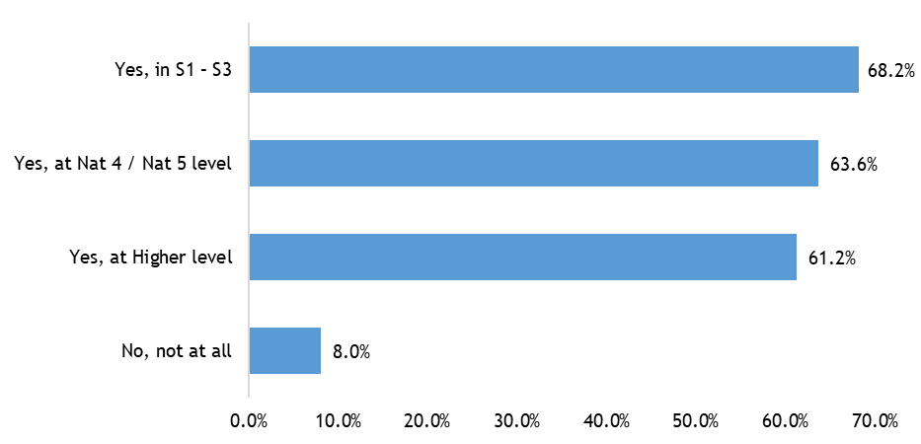

Nearly two-thirds of young people are able to take Modern Studies as a stand-alone subject in school at some stage. Only 8% were not offered Modern Studies at all.

***‘Did your school cover “Citizenship” in Personal and Social Education Classes?’***

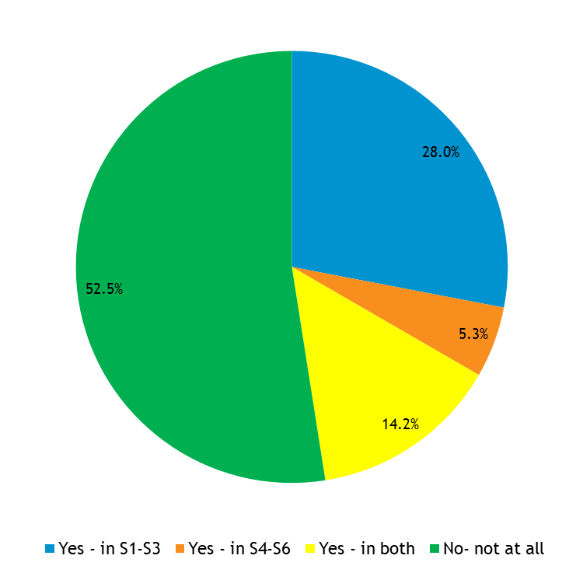

Respondents were given four options and were asked to select all that apply.

Over **half of the young people** who replied to this question said their school did not cover ‘citizenship’ in Personal and Social Education (PSE) classes at all.

On the other hand, only one in seven young people said their school covers ‘citizenship’ in PSE classes throughout high school (between S1 and S6).

**Protection of Workers**

The Scottish Parliament’s Economy, Energy and Fair Work Committee is looking at a Bill which would make it a specific crime to assault or threaten someone who has to enforce age restrictions (on products like alcohol and tobacco or services like gambling and tanning) and people who work in retail. That also includes places that serve food (like cafes and restaurants) as well as people who deliver things (like takeaways or online orders). These questions will help the Committee find out how safe young people feel at work, and whether they feel working in retail and selling age-restricted goods should be treated differently to working in other kinds of jobs.

|  |
| --- |
| “It is interesting to read that most young people feel retail workers are just as likely to receive abuse or be assaulted at work as other workers who deal with the public. It shows that this issue goes beyond the scope of just a particular field of work, and shows changes need to cover a wider scope rather than a particular one. It’s important that young people get involved in the discussions about this topic because the retail sector is one of the biggest employers of young people, and as such this will have a great impact on them.”  - Calum Nimmo MSYP, Convener (Jobs, Economy, and Fair Work) |

***‘Have you experienced or witnessed threatening or abusive behaviour towards retail workers in any of the following situations?’***

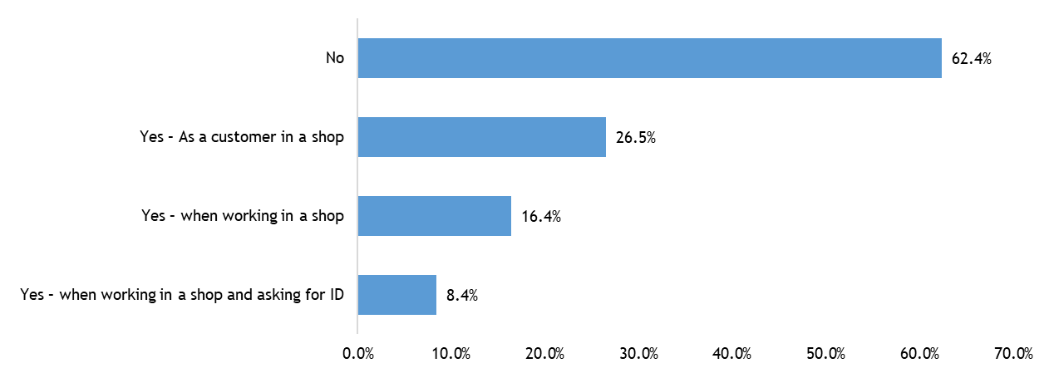

*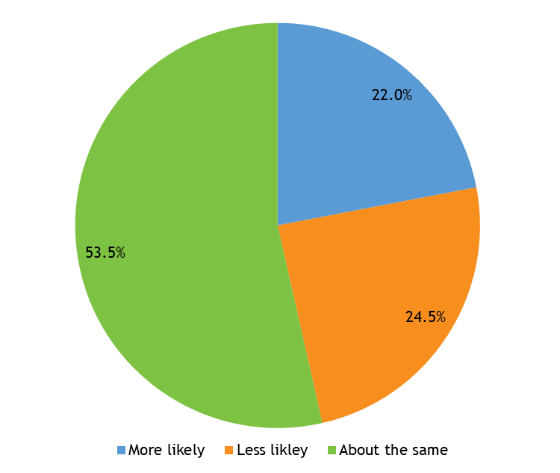****‘Do you think retail workers are more or less likely to be threatened or assaulted at work than other workers who deal with the public (e.g. bus drivers, traffic wardens, paramedics etc) and why?’***

Just over one fifth of young people think retail workers are more likely to be threatened or assaulted at work than other workers who deal with the public. Young people suggested this is because retail workers are **less respected** or have **less authority** than other workers who deal with the public; because retail workers **tend to be younger** than other people who deal with the public; or because of the **types of product** retail workers are selling, such as cigarettes and alcohol.

On the other hand, nearly one quarter of young people are less likely to be threatened or assaulted at work than other workers who deal with the public. Young people suggested this is because retail environments tend to be **less stressful or high pressure situations**, and therefore people are less likely to behave aggressively towards retail workers than towards other public-facing workers such as paramedics or traffic wardens.

**‘Feeding Scotland Sustainably’**

The Scottish Parliament has agreed the Climate Change (Emissions Reductions Targets) (Scotland) Act 2019 on a cross-party basis. Implementation - and particularly just transition – require action and/or acceptance of policy solutions from people across Scotland.

These questions addressed the fundamental question of how as a society we can balance meeting people’s basic and urgent needs (food, housing, safety, transport) with the climate emergency. Responses will help the Scottish Parliament and the Environment Climate Change and Land Reform Committee think about how we engage and inspire Scotland on this issue.

|  |
| --- |
| “Feeding Scotland Sustainably is an important part of ensuring a just transition. It is clear from the *#WhatsYourTake* survey that young people believe we should support farmers through subsidies to help ensure sustainable methods of farming can be adopted, take steps to reduce food waste by encouraging the sale of more sustainable, unpackaged produce, and provide support for people to grow their own produce at home. Young people should continue to be able to make their voices heard on how we can balance our incredibly important food-based needs with the urgent need to tackle the climate emergency.”  - Ryan Kelly MSYP, Convener (Social Security) |

***‘In order to reach our climate emission targets, as a society we need to look at how we create a food system which lowers emissions whilst ensuring a fair society for those who produce and consume products.’***

Young people were asked to rank eight actions based on what they think they could do now to achieve this goal. The actions were ranked as follows:

1. Reducing and recycling food waste.
2. Buying locally sourced produce.
3. Buy less processed and packaged food.
4. Eating more seasonal fruit and vegetables.
5. Buying organic and sustainably approved options.
6. Growing your own fruit and vegetables.
7. Advocating for carbon labelling of all food products.
8. Eating less animal products (e.g. meat and dairy).

***‘Shifts in food production and land management will impact several sectors across society. Thinking about your choices above, how can we do this in a fair and equitable manner, ensuring people do not lose employment or access due to increased costs, for example farmers and/or people experiencing poverty?’***

Responses to this question were sorted by theme. Suggestions for shifting food production and land management in a fair and equitable way included:

* Ensuring there is **support for farmers**. This could include subsidies to ensure farming methods are sustainable, and support for farmers to diversify to alternative farming methods or products.
* Taking steps to **reduce food and non-recyclable waste** by providing food waste bins to every home, working with supermarkets and other retailers to donate leftover food to foodbanks, and encouraging retailers to sell more unpackaged and sustainable products.
* **Subsidising sustainable food options** such as local produce to bring the cost in line with less environmentally-friendly products and make it more affordable for everyone.
* **Encouraging people to buy local and seasonal produce**, and providing support for people to grow their own fruit and vegetables at home.
* **Improving environmental education** in schools for all young people to enable them to make sustainable choices.
* **Involving those who may be affected by changes** to food production and land management in any discussions and decisions which will have an effect on their lives.