Sunday May 10 2026

Dear <TEACHER / LECTURER / YOUTH WORKER NAME>

Scottish Youth Parliament Elections 2026 in <LA / NVO NAME> - Candidate Application

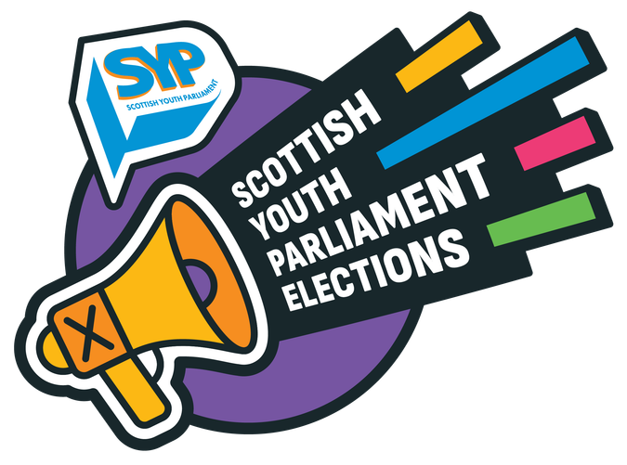
I am contacting you to let you know the following young people who attend your <school / college / university / group> have applied to stand as a candidate in <LA / NVO NAME> in the upcoming Scottish Youth Parliament (SYP) Election:

- <list candidate names>

The Scottish Youth Parliament Elections are facilitated by youth workers in each of Scotland’s Local Authorities and several National Voluntary Organisations. I am the Election Coordinator for <LA / NVO NAME> and will be the main point of contact <YP NAMES> during the SYP Election process.

The Scottish Youth Parliament (SYP) is the democratically elected voice of Scotland’s young people. Every two years, around 160 members of the Scottish Youth Parliament - MSYPs - aged 14 to 25 are elected to represent young people in every part of Scotland and to campaign for positive change. The next SYP Elections will take place in November 2026. You can find more information on the SYP website here, including an information sheet for <schools / youth workers> and links to other resources you can use to help the young people you work with find out more about the Scottish Youth Parliament.

As the Election Coordinator for <LA / NVO NAME>, I will:

- Keep in touch with young people in <LA / NVO NAME> through the election process.
- Help young people to take part in local and national events and training, and to reflect on their experiences through the process.
- Support young people to prepare their candidate profiles and promote their candidacy to young people in their constituency.
- Share local and national opportunities for candidates to get involved in.
- Coordinate the voting process and results announcements within <LA / NVO NAME>.
- Support successfully elected MSYPs in their roles after the election and help unsuccessful candidates to explore other opportunities to participate in <LA / NVO NAME>.

In <LA / NVO NAME>, the SYP Election process will include:

- <add details of the process and key dates in your LA / NVO>

As part of our duty of care, we require parental or carer consent for candidates under the age of <16 / 18> to take part in the SYP Elections. We have contacted the parents / carers of the young people who attend your <school / college / university / group> to ask them to complete a consent form.

How you can help to promote the SYP Elections

The Scottish Youth Parliament represents all young people in Scotland, and we want to make sure all of the young people in <LA / NVO NAME> can take part in the SYP Elections this year, either as candidates or by voting for the MSYPs who will represent them over the next two years.

You could help us to promote the SYP Elections by:

- <Add details of how teachers / youth workers / etc could help to promote the elections in your LA / NVO. This could include, for example:
  - Putting up posters or sharing flyers about the SYP Elections.
  - Facilitating a workshop or presentation about the Scottish Youth Parliament.
  - Inviting current MSYPs to visit to talk about their experiences and to consult young people on issues they care about.
  - Including information about the SYP Elections in newsletters.>

Voting in the SYP Elections will take place between 2nd and 15th November 2026, and young people will be able to vote by <add details of how voting will take place in your LA / NVO>. We will share more information about how you can support young people in <date / month etc>.

How to contact me

If you have any questions or would like to contact me at any point during the SYP Elections process, my contact details are:

<Add contact details for all Election Coordinators – name, email address, phone number>

Thank you for supporting <YP NAME>’s interest in taking part in the Scottish Youth Parliament Elections this year, and for encouraging their interest in democratic participation.

Yours sincerely,

<YOUR NAME>
Election Coordinator - <LA / NVO NAME>

