Sunday May 10 2026

Dear Parent / Carer,

Scottish Youth Parliament Elections 2026 in <LA / NVO NAME> - Candidate Application

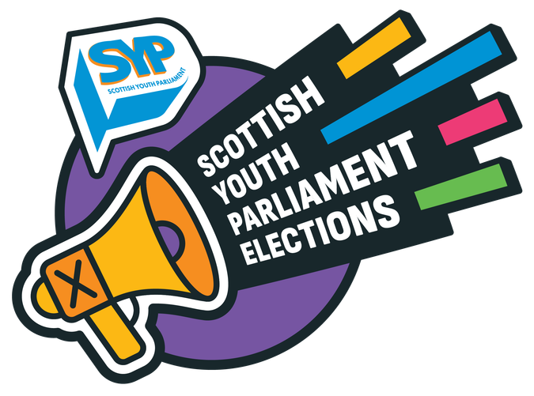
I am contacting you to let you know your young person, <YP NAME>, has applied to stand as a candidate in <LA / NVO NAME> in the upcoming Scottish Youth Parliament (SYP) Election.

The Scottish Youth Parliament Elections are facilitated by youth workers in each of Scotland’s Local Authorities and several National Voluntary Organisations. I am the Election Coordinator for <LA / NVO NAME> and will be the main point of contact for you and <YP NAME> during the SYP Election process.

The Scottish Youth Parliament (SYP) is the democratically elected voice of Scotland’s young people. Every two years, around 160 members of the Scottish Youth Parliament - MSYPs - aged 14 to 25 are elected to represent young people in every part of Scotland and to campaign for positive change. The next SYP Elections will take place in November 2026. You can find more information on the SYP website here and an information sheet for parents and carers about the SYP Elections here.

As the Election Coordinator for <LA / NVO NAME>, I will:

- Keep in touch with young people in <LA / NVO NAME> through the election process.
- Help young people to take part in local and national events and training, and to reflect on their experiences through the process.
- Support young people to prepare their candidate profiles and promote their candidacy to young people in their constituency.
- Share local and national opportunities for candidates to get involved in.
- Coordinate the voting process and results announcements within <LA / NVO NAME>.
- Support successfully elected MSYPs in their roles after the election and help unsuccessful candidates to explore other opportunities to participate in <LA / NVO NAME>.

In <LA / NVO NAME>, the SYP Election process will include:

- <add details of the process and key dates in your LA / NVO>

Consent to participate in the SYP Elections <amend according to your LA / NVO policies and procedures, and age of candidate>

As part of our duty of care, we require parental or carer consent for candidates under the age of <16 / 18> to take part in the SYP Elections. This allows <YP NAME> to participate in online and in-person meetings, events, and campaigning activities, and to receive election-related communications where appropriate.

Please complete and return the attached consent form by <DEADLINE DATE>.

If the consent form is not returned by this deadline, <YP NAME> may not be allowed to continue as a candidate.

How to contact me

If you have any questions or would like to contact me at any point during the SYP Elections process, my contact details are:

<Add contact details for all Election Coordinators – name, email address, phone number>

Thank you for supporting <YP NAME>’s interest in taking part in the Scottish Youth Parliament Elections this year, and for encouraging their interest in democratic participation.

Yours sincerely,

<YOUR NAME>
Election Coordinator - <LA / NVO NAME>

